GBA 5140 Statistics Essentials for Business Analytics

Problem Set 11

Other Applications of Chi Square Test

**Problem 1**

An ambulance service responds to emergency calls for two counties in Virginia. One county is an urban county and the other is a rural county. A sample of 471 ambulance calls over the past two years showed the county and the day of week for each emergency call. Load “Data-Ambulance.csv” into RStudio. Write R code for the following tasks. ***Post your R code and RStudio output (console output) below each task.***

1. Develop the null and alternative hypotheses to test for independence of the county and the day of the week, then use both p-value approach and critical value approach for hypothesis testing with 5% level of significance.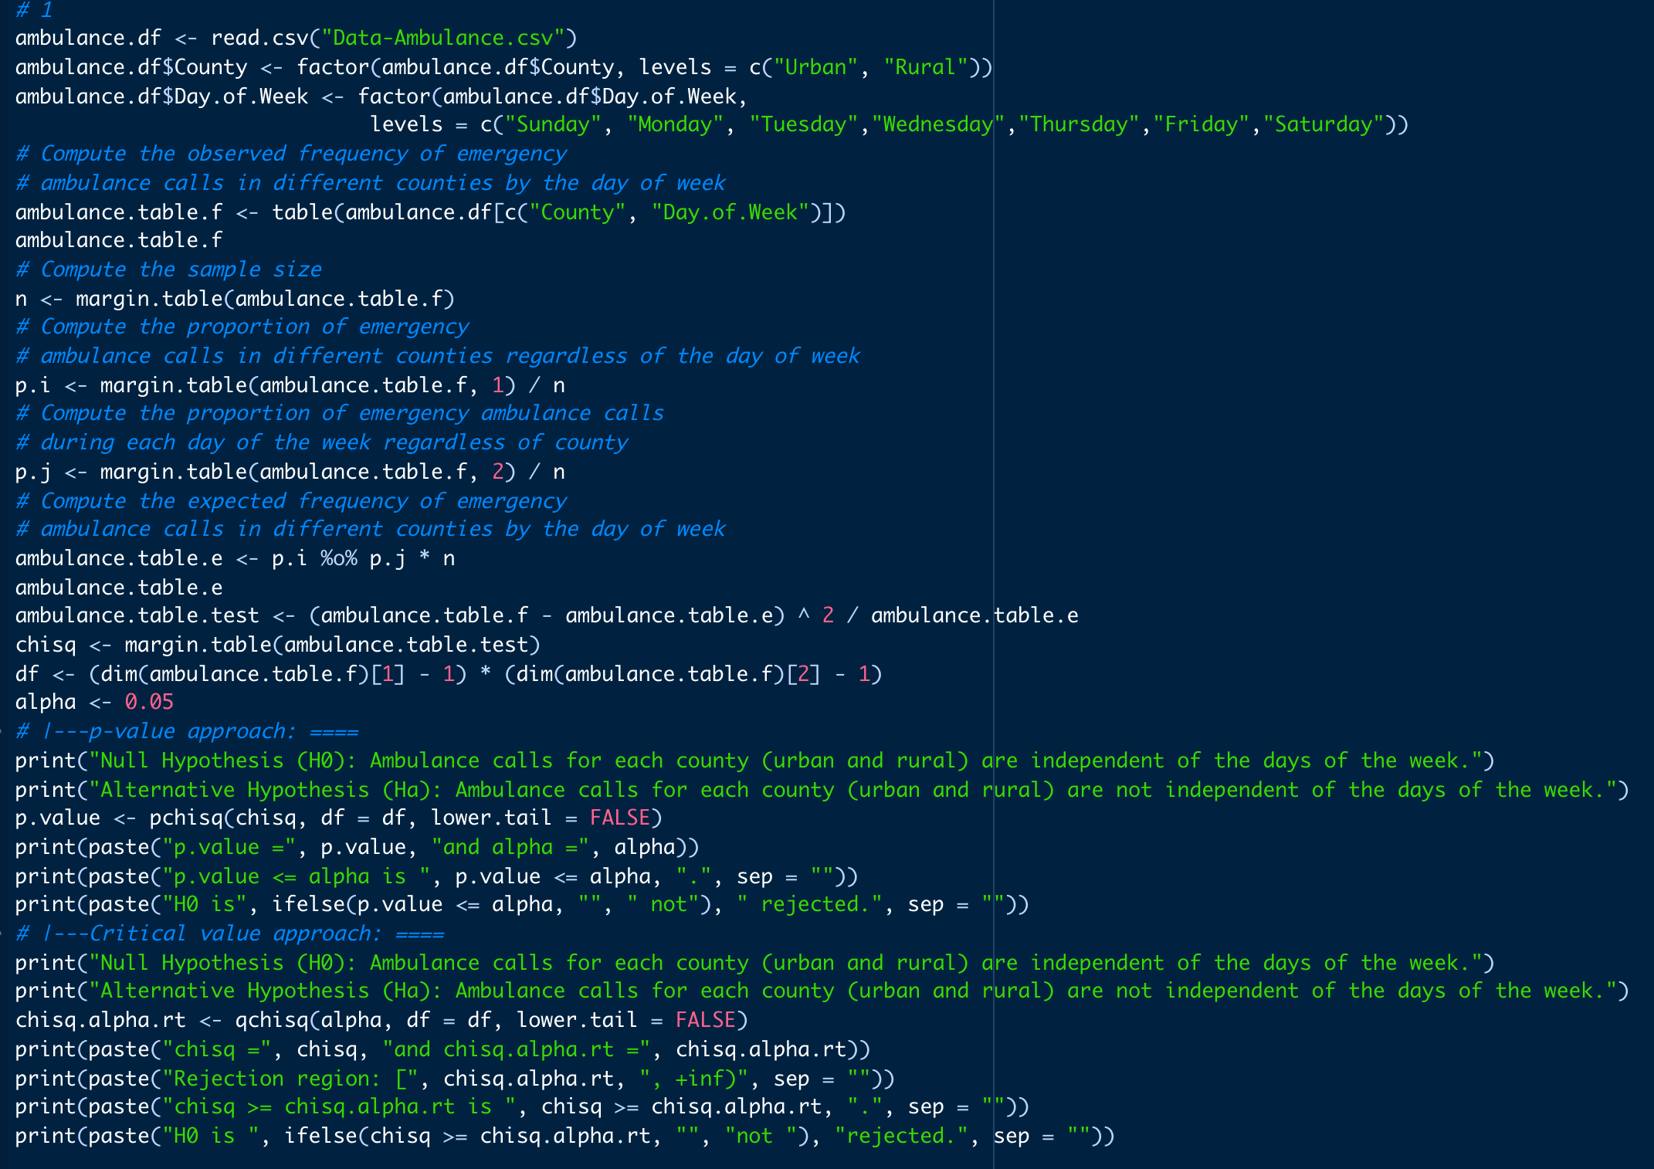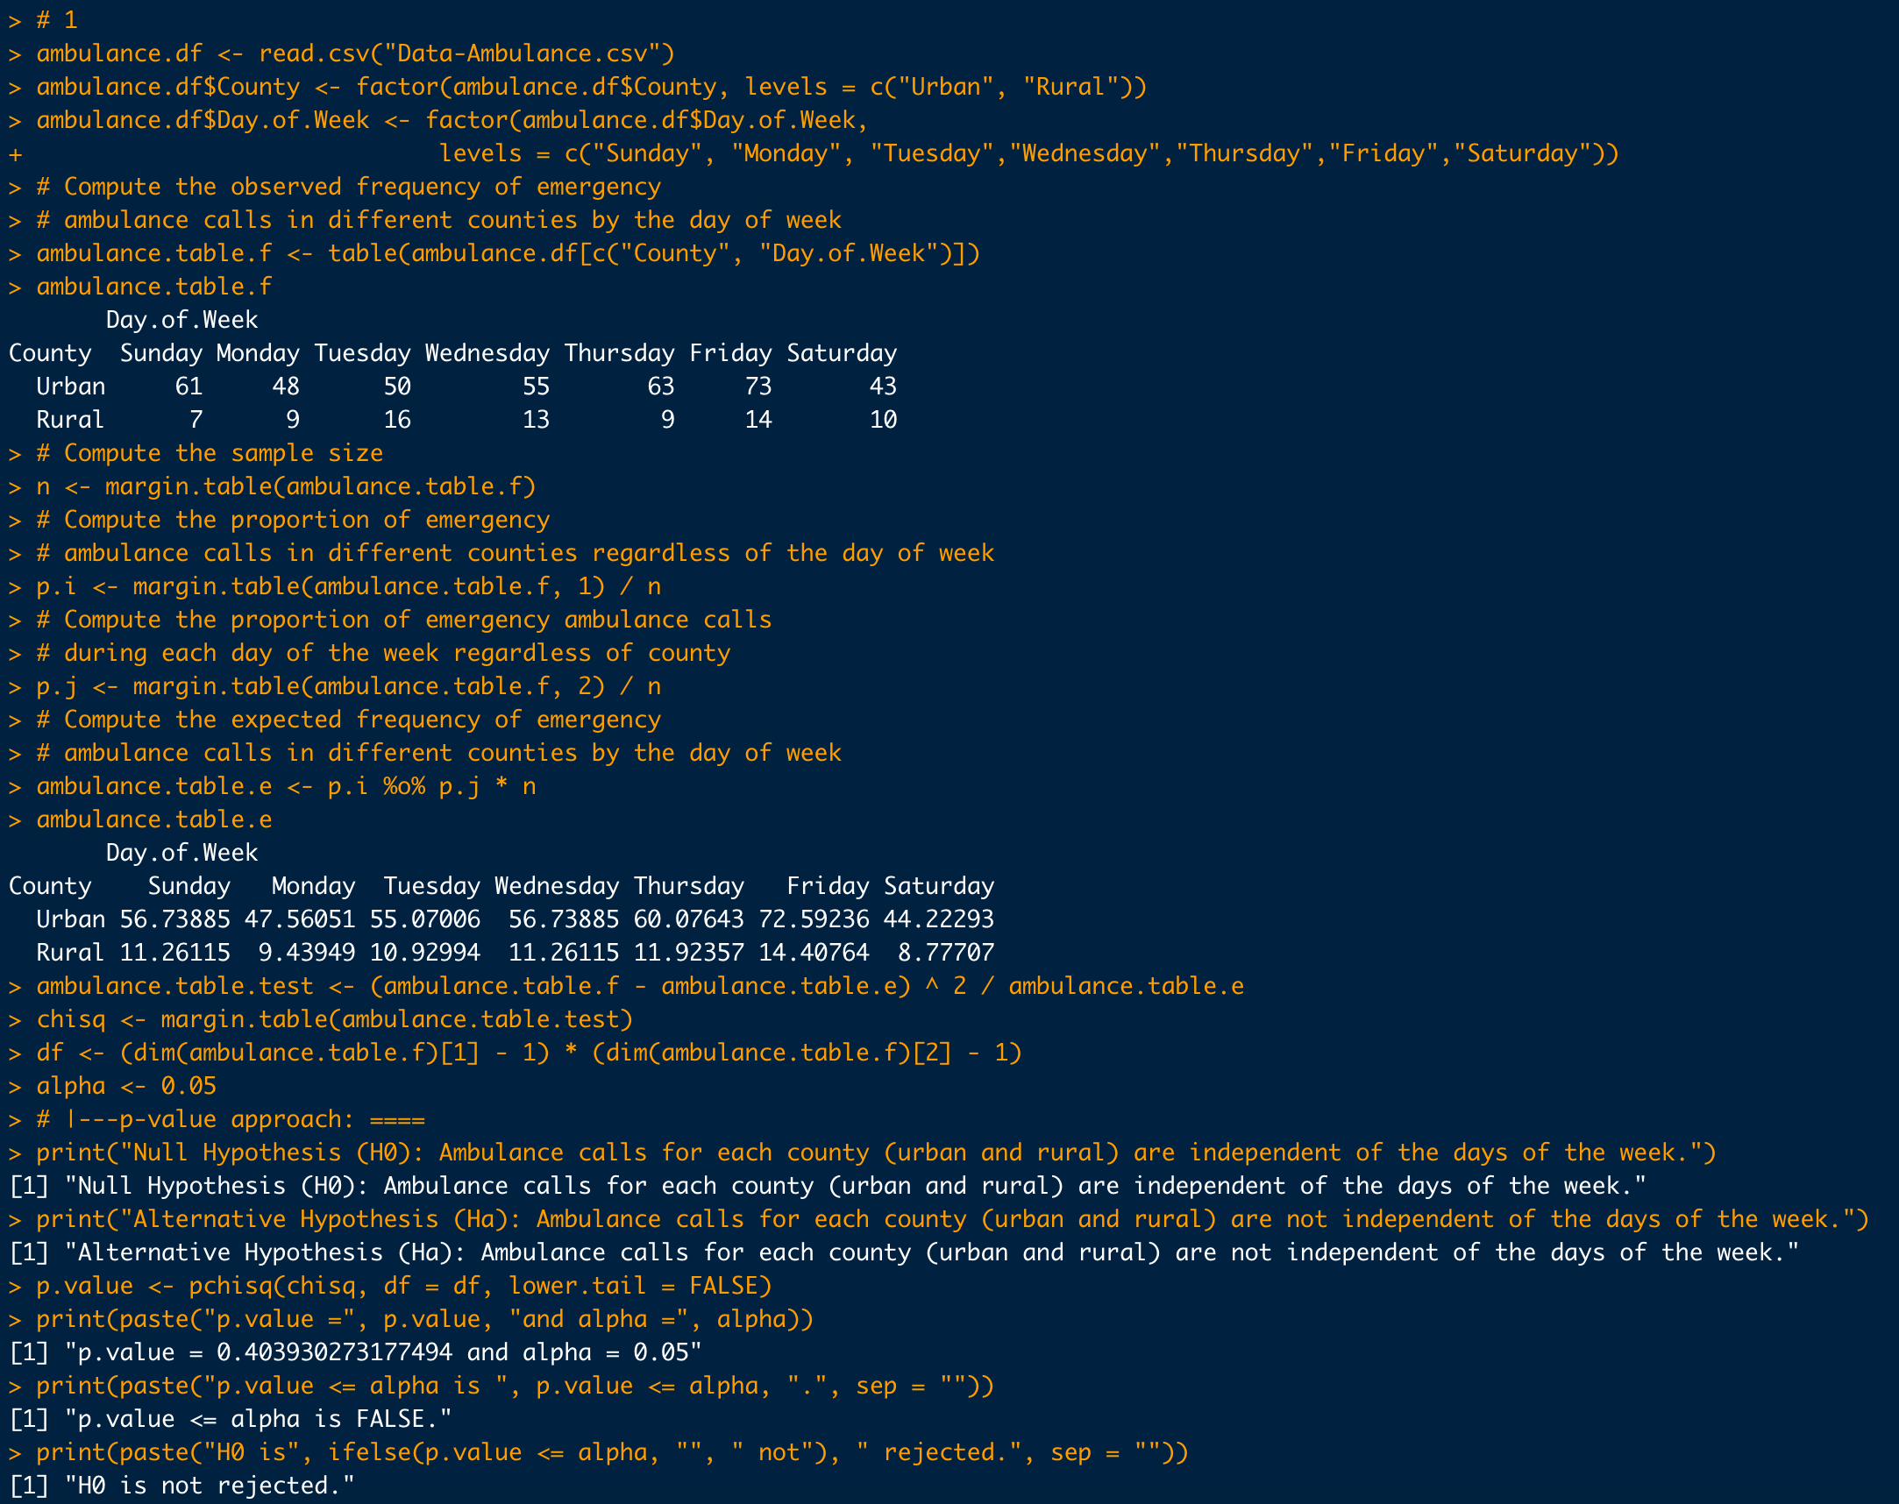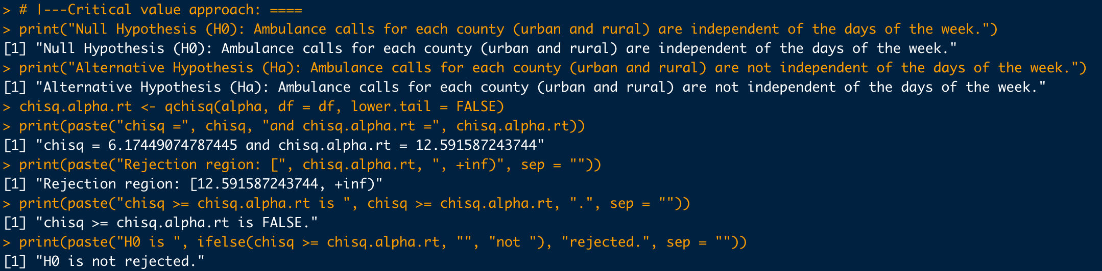

**Problem 2**

“Data-Grades.csv” contains a random sample of final examination grades for a college course. Load “Data-Grades.csv” into RStudio. Write R code for the following tasks. ***Post your R code and RStudio output (console output) below each task.***

1. Develop the null and alternative hypotheses for goodness of fit test assuming a normal distribution of the grades, then use both p-value approach and critical value approach for hypothesis testing with 5% level of significance.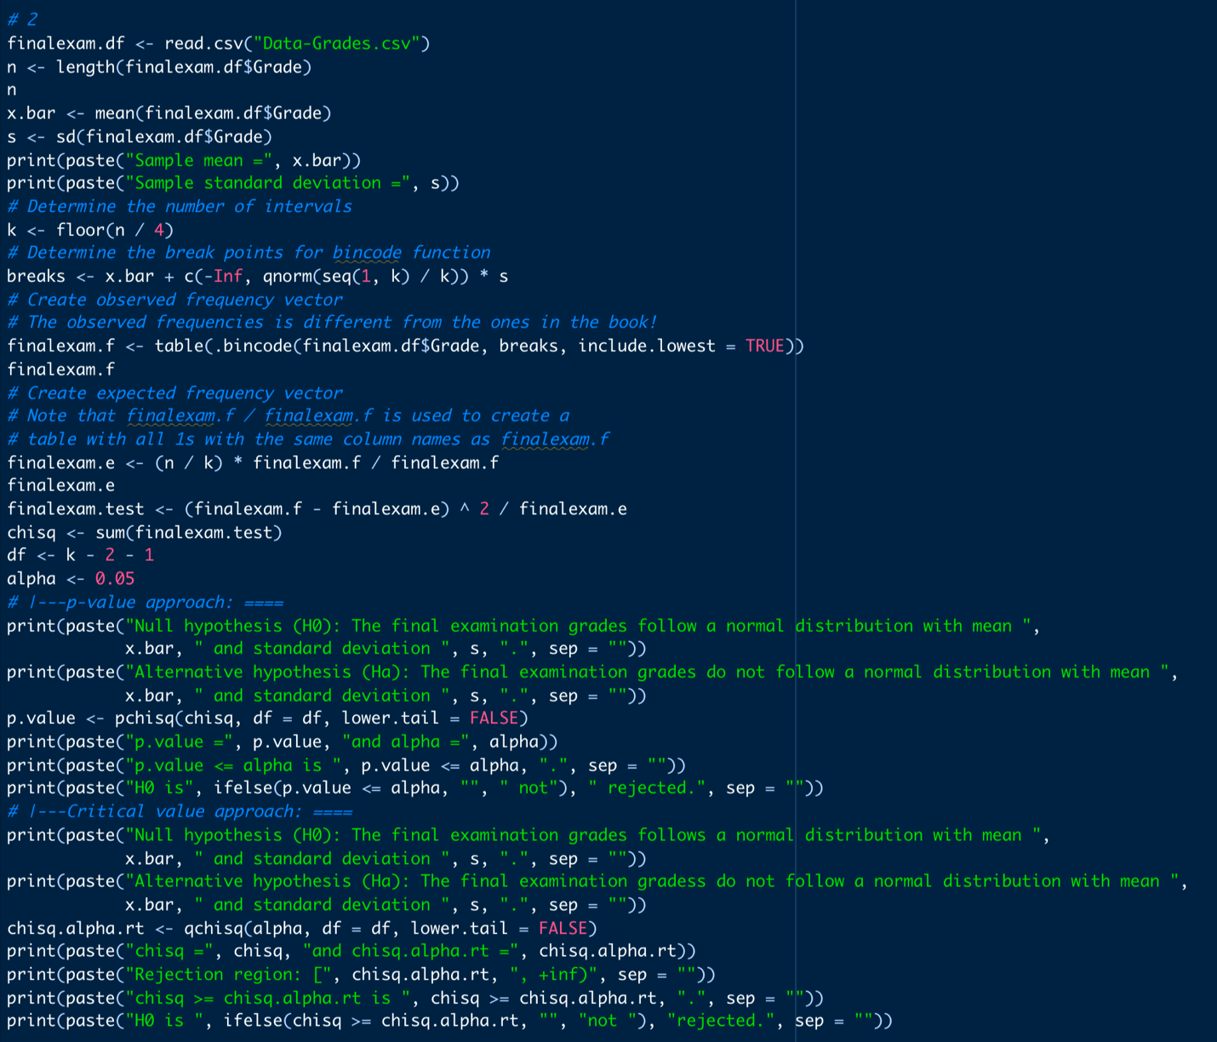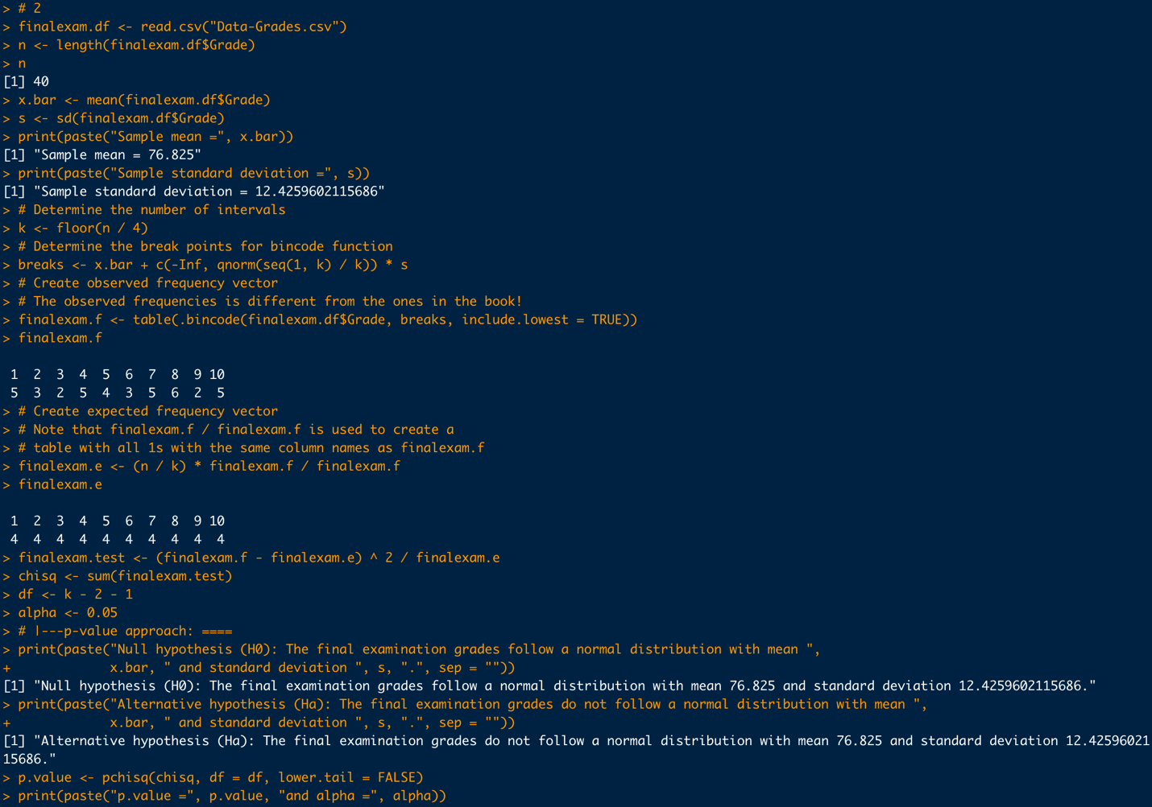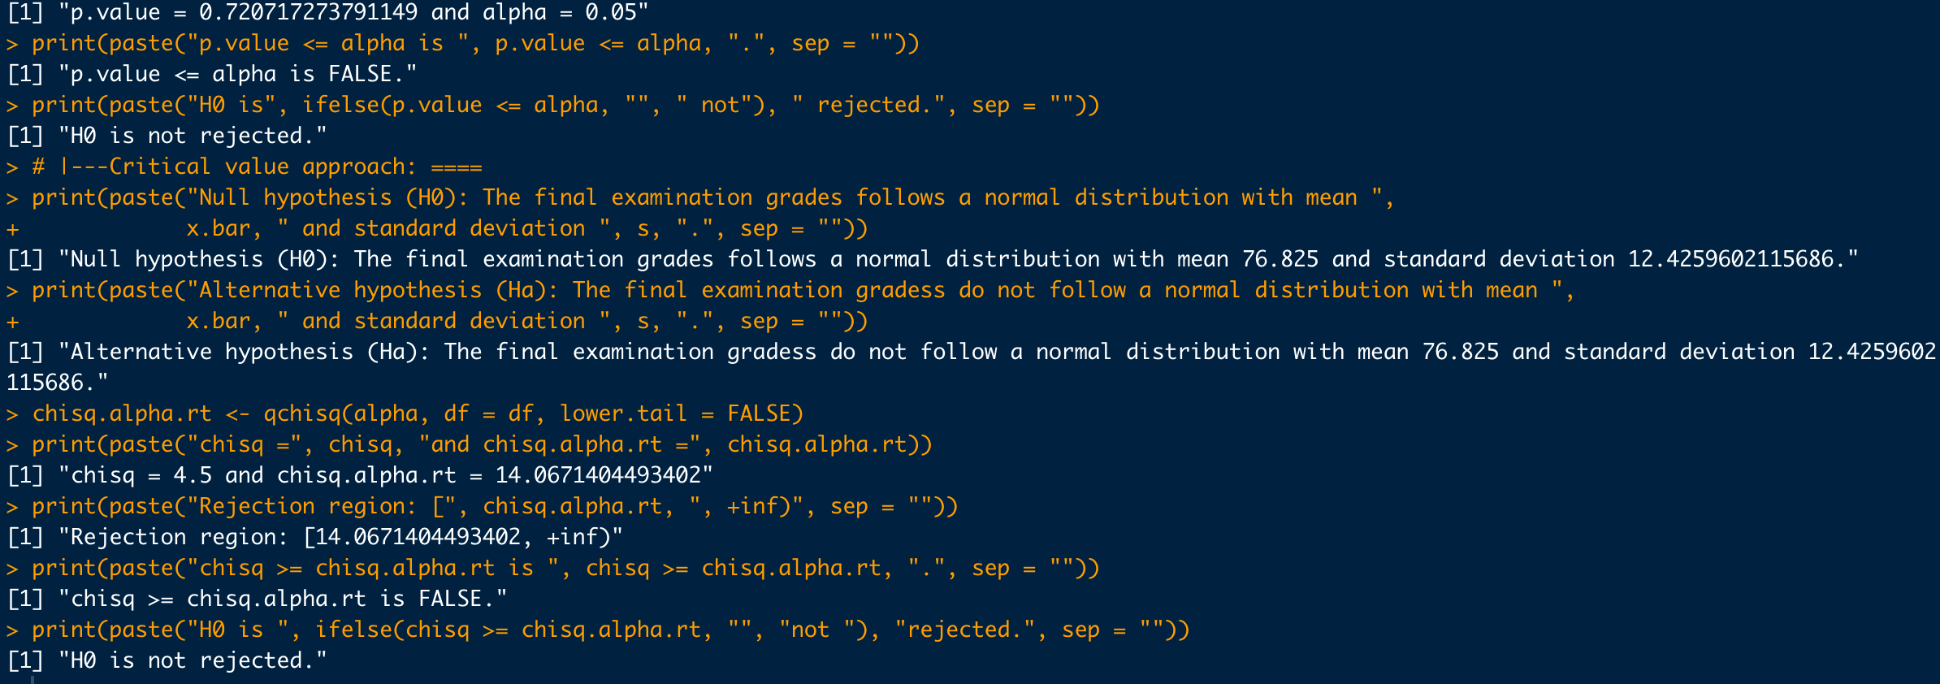

**Problem 3**

“Data-Flights.csv” contains a sample of flight status (ontime or delay) of several airlines (carriers). Load “Data-Flights.csv” into RStudio. Write R code for the following tasks. ***Post your R code and RStudio output (console output) below each task.***

1. Develop the null and alternative hypotheses to test whether the proportion of delayed flights is the same across all carriers, then use both p-value approach and critical value approach for hypothesis testing with 5% level of significance.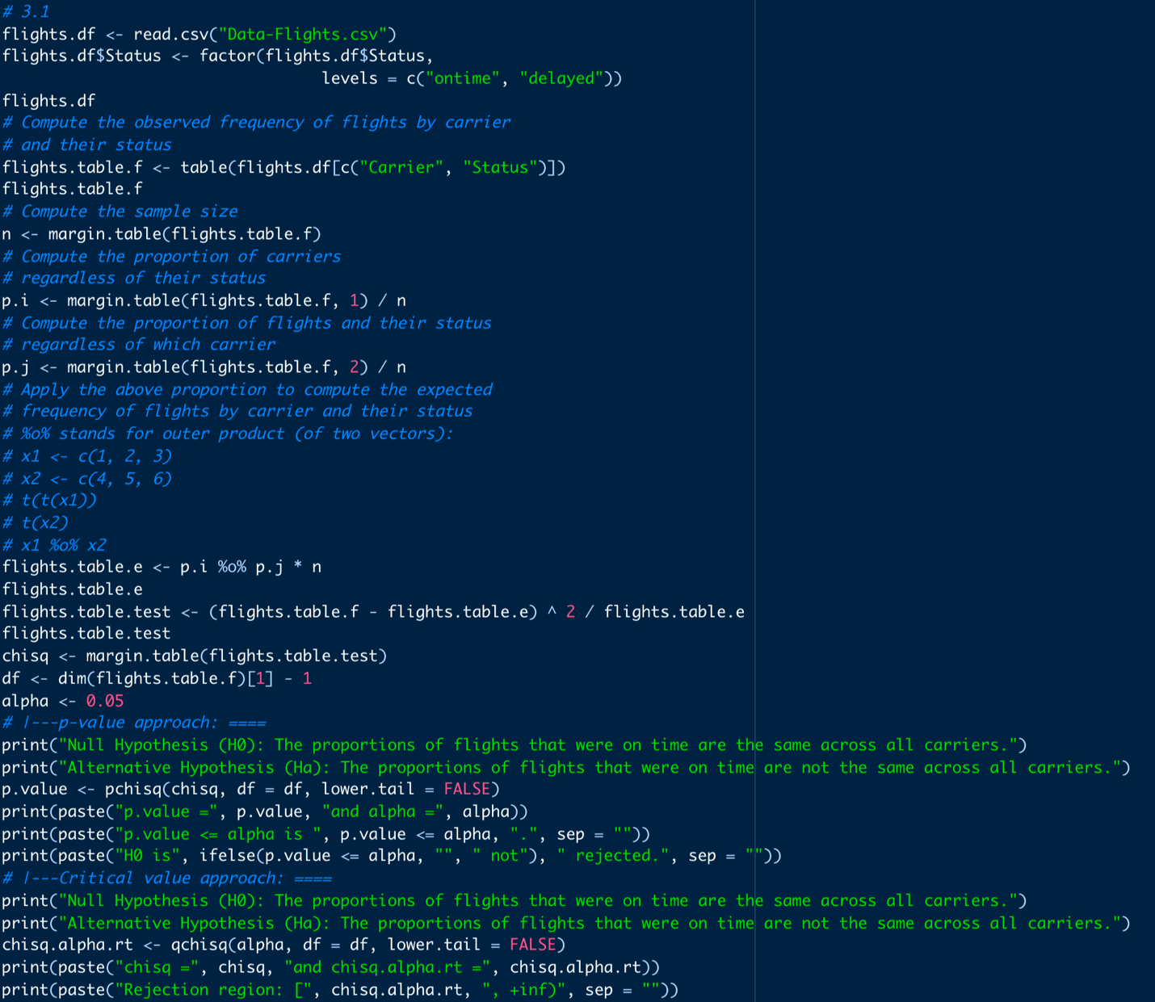 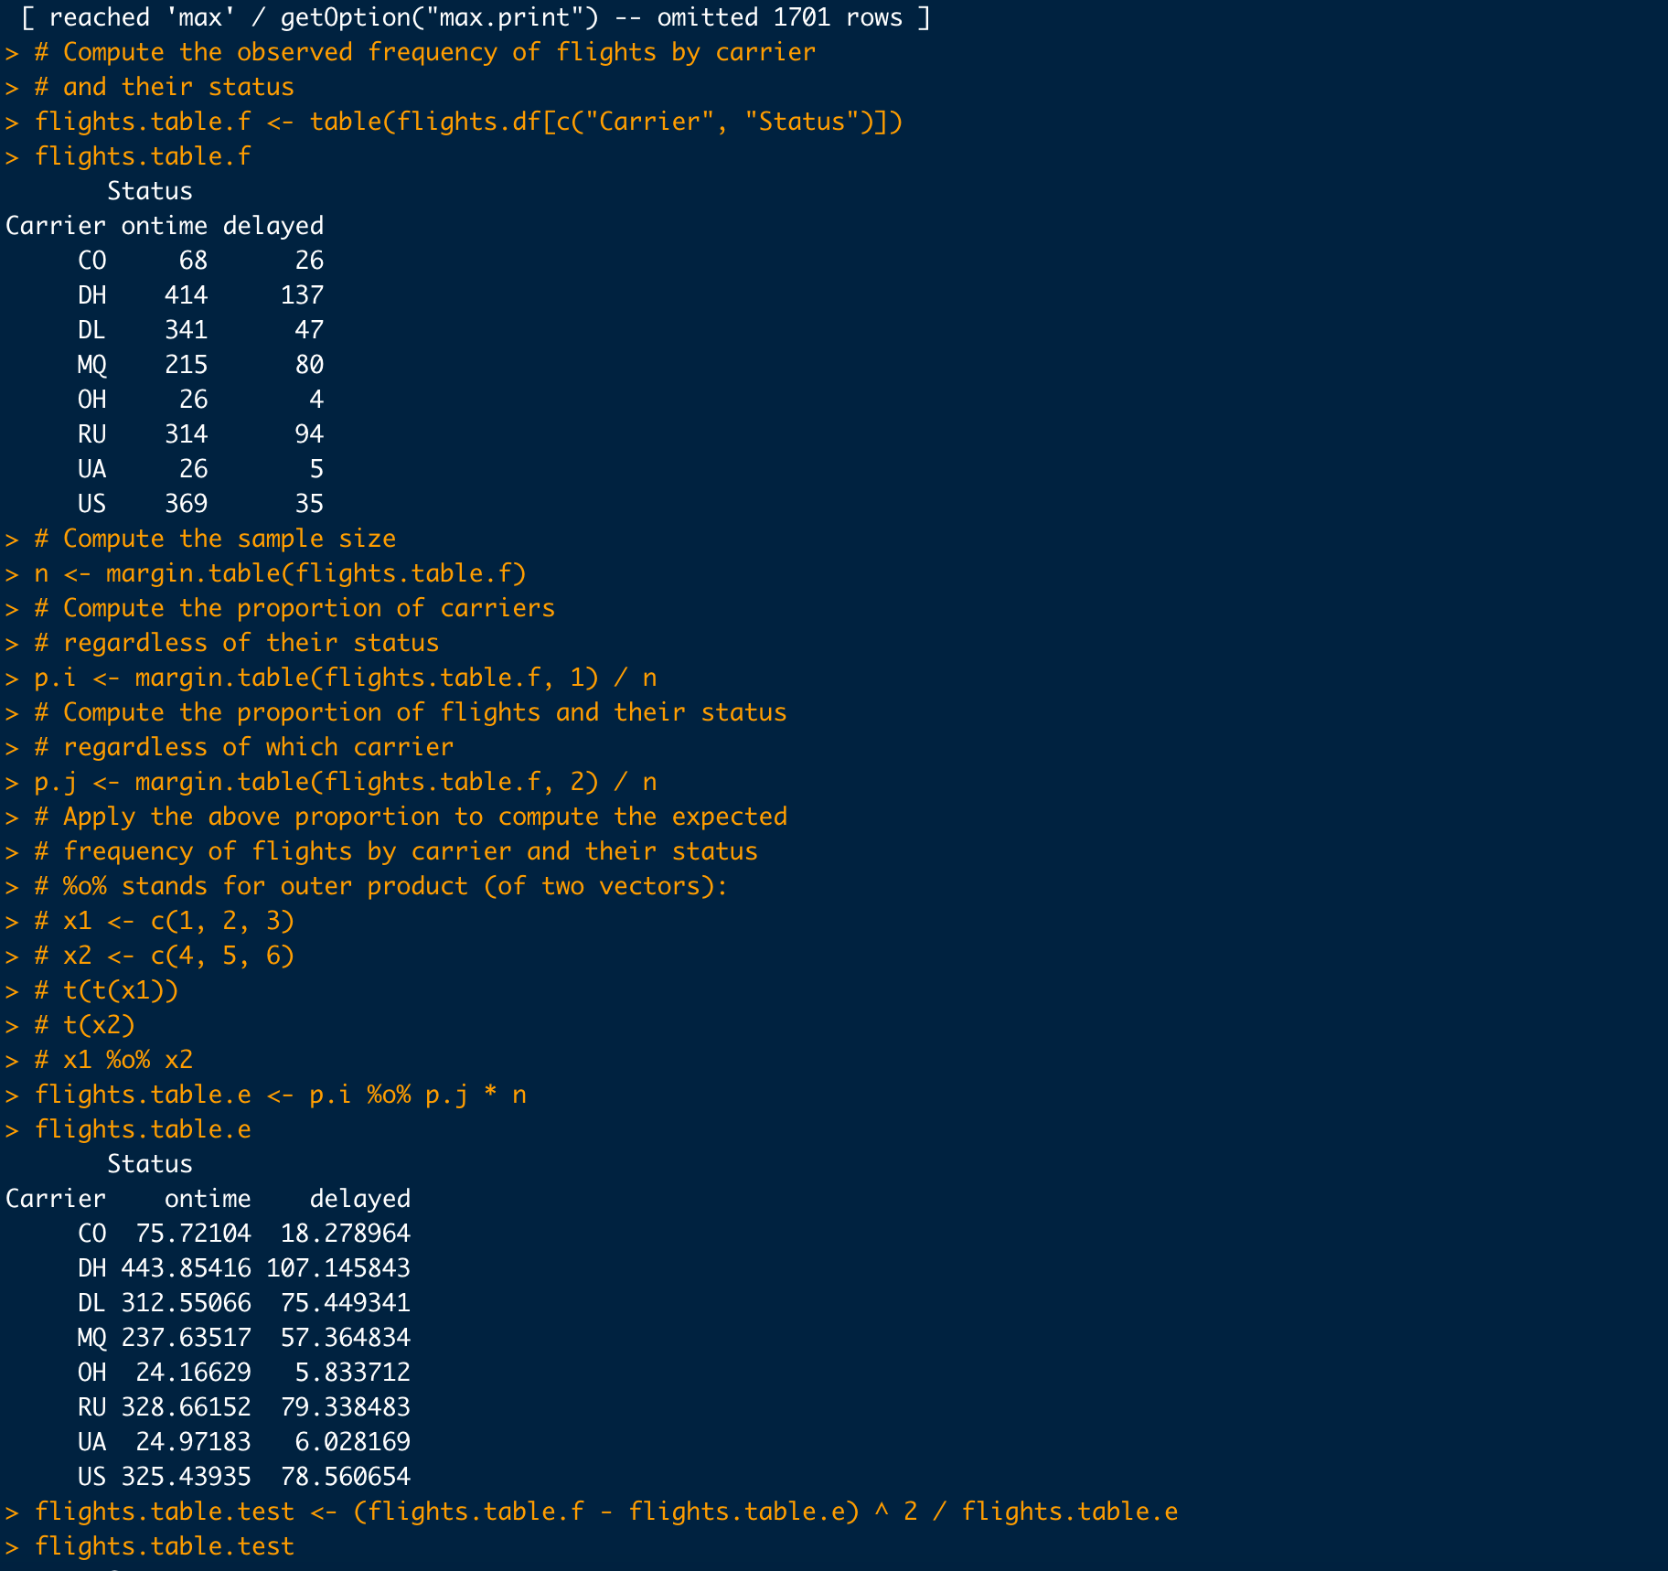
2. Identify pairwise carriers whose proportions of delayed flights are significantly different. Develop the null and alternative hypotheses for each pair and follow the Marascuilo procedure with 5% level of significance.

